THE HUNGARIAN VIZSLA CLUB OPEN SHOW

17/03/2019

I would like to thank the HVC for their kind invitation to judge their open show. I thoroughly enjoyed my day and want to thank the committee for their hospitality, exhibitors for the lovely entry and Mandy Morton for stewarding.

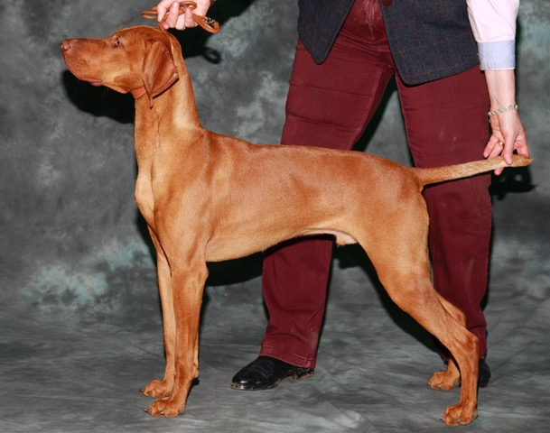Minor Puppy D (3, 1 abs)

1 Mills’ KARROUKI WILDFIRE. 8 month old with masculine head, good substance, nice bone, neat feet, level top line with good rear angulation. Correct tail carriage. Moved well when eventually settled.

2 Connolly’s KARROUKI WILDFLAME. Litter brother, of smaller mould but has similar attributes. Giving his handler a hard time with his puppy antics.

Puppy D (2)

1 K WILDFIRE

2 K WILDFLAME

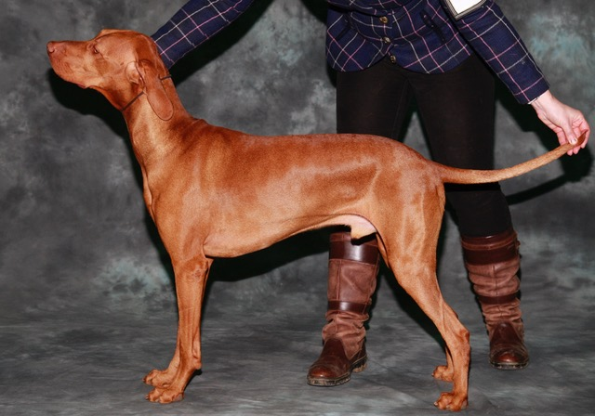Junior D (4, 2)

1 Harrison’s ALFIZSBET PIKE O’STICKLE VON ARGYROS. 15 month, well up to size, good head with kind expression and correct ear set, good spring of ribs, level top line, well angled hind quarters. Moved ok.

2 Lloyd-Jones Zvedris’ VADASZPAJTAS AKNA-AGLOOLIK. First show for owner and dog so not shown to best advantage, moved ok when settled. Could carry more weight as looking slightly lean. Hope the exhibitor perseveres as the dog has promise.

Yearling D (3)

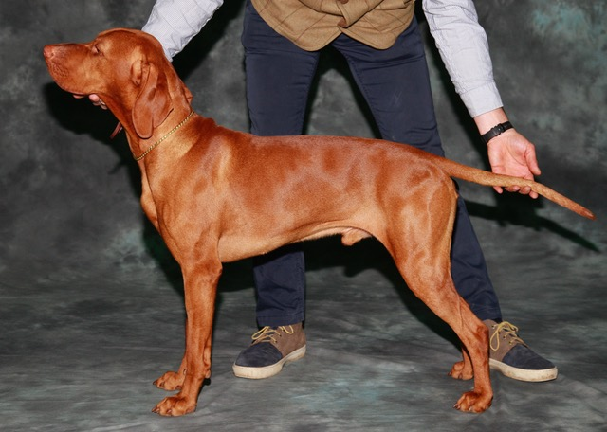1 Dorogi’s NEMZET KINCSE ORION. Masculine head with good eye shape and colour, neat ears, good substance, good front and depth of brisket, level top line, well angulated hindquarters which he used to power round the ring. Lost on maturity to open dog winner. Res Best Dog and Res Best in Show.

2 Cruickshank’s TOPAERIS SHADOW, another nice dog just not the outline of winner. Good head, neck, forechest and quarters. Moved OK

3 V AKNA-AGLOOLIK

Post Grad D (2, 1)

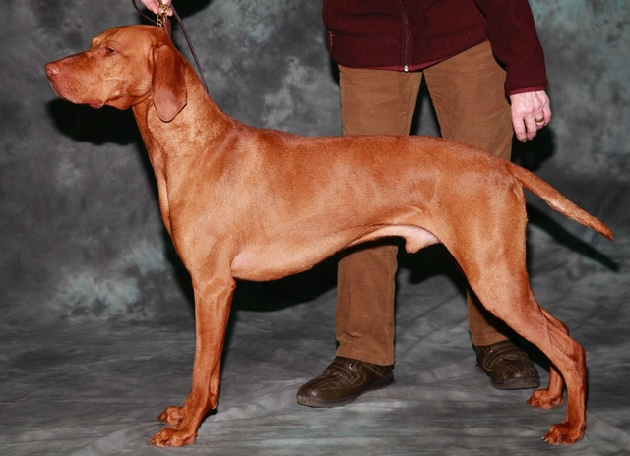1 White’s LUTRA LORD ADMIRAL BY ARUNSZVA. 5 year old mature dog. Stood alone but deserved his placing. Good head with nice dark eye, good depth of chest and length of rib, well angulated hindquarters. Moved well.

Limit D (3)

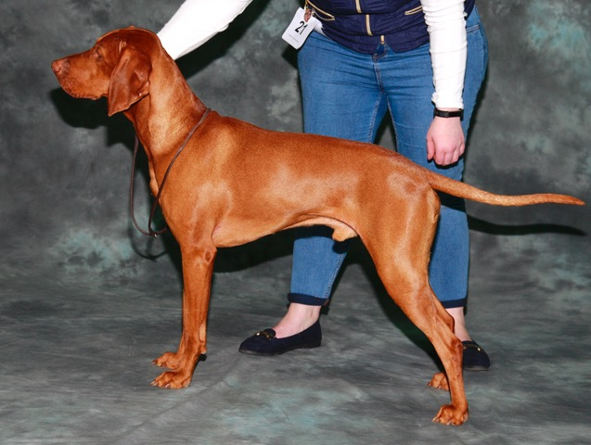1 Elliot’s ALDOM DARK N’ STORMY. Balanced dog with masculine head, strong neck, straight front, but feet could be tighter. He has a level top line on the move. Good rapport between handler and dog.

Barwick’s BEQUERELLE VAGABOND. Darker coloured dog of good type, nice head with good ear set, well balanced body, well-muscled rear but did not move as well as one.

3 Northwood’s NORTHEY EMPEROR DEL ACQUADORO.

Open D (5)

1 Harper’s SH CH MAGNUS FORTUNA PITSWARREN JW. True representative of the breed, worthy champion with excellent head and expression. Good front, bone and feet, in good condition. Moved round the ring with style and purpose. Best Dog and worthy Best in Show.

2 Barrett’s KARASZY’S GLORIOUS LEGACY. Clean head with kind expression, good neck into good shoulders, and good depth of rib cage, well-muscled, well set tail. Moved well

3 Da Silva’s SH CH BOURNEHOUSE CRISPIN

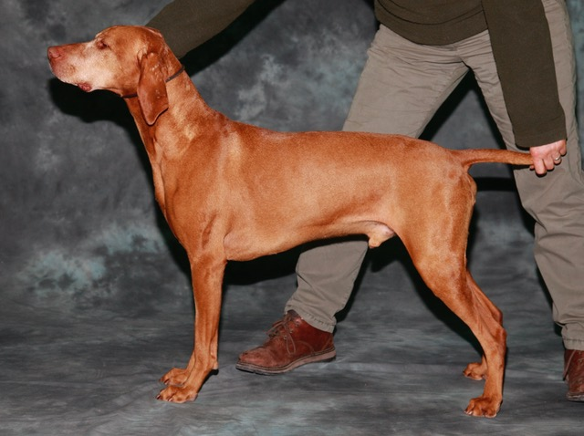Veteran D (3, 1)

1 Griffiths & Scott’s CH ULURUDAWN CARDINAL MARKER. 8 ½ year old champion of good length and height. Noble head, dark eye, good lay of shoulder and good muscle tone. Moving slightly wide in front today.

2 White’s PARCROFT PIROS BY ARUNSZVAR. 10 year old, another honest type dog. Slightly overweight which is allowed at this age and showed in his movement.

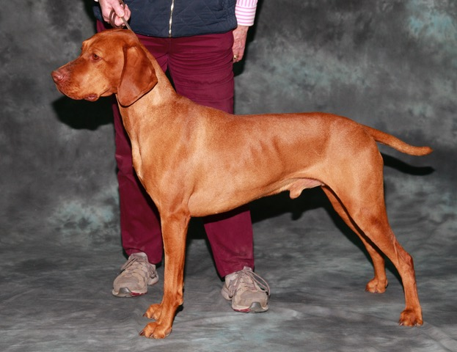Field Trial D (2)

1 Harris’ SZAJANI SZEDER. 4 year old workmanlike dog, well balanced, good shoulder placement, good rear angulation. Moved well.

2 Mills’ KARROUKI WINDFIRE JW. Nice type with good head and kind expression, good bone, well-muscled. Not so settled in movement as first.

Minor Puppy B (5, 1)

1 Harper’s PITSWARREN SORBONNE. Beautiful 6 month puppy at her first show, just right for age. Lovely head with typical quizzical vizsla expression, good body, good moderate angulation. Moved well when settled. Best Puppy in Show.

2 Harris & Kleinman’s GOLDSTAR MISS TEEQ FROM SZAJANI. Another lovely 6 month old puppy, nice head, good legs with neat feet, good body and hindquarters. Moved well

3 Warnes’ LUCKVILLE DIGITALIS BY DEBIAN

Puppy B (3, 1)

1 P SORBONNE

2 L DIGITALIS BY D. Third in previous class behind 2 lovely puppies. 8 month old with a pretty head, good front and rear. Moved much better in this class with a level top line.

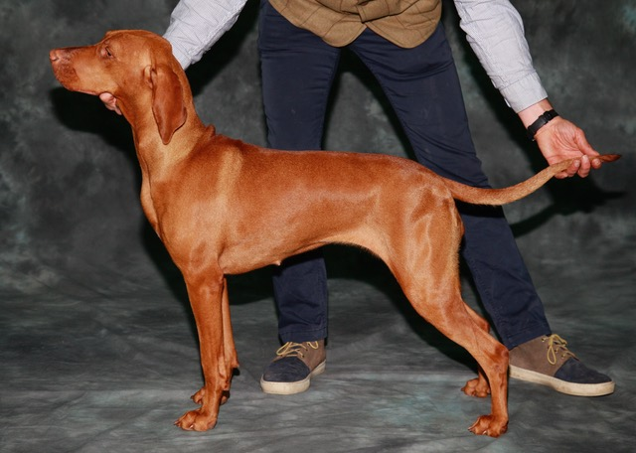Junior B (3)

1 Dorogi’s DAENERY’S LABSKE LHOTY. Just out of puppy, nicely shaped bitch with good expression, dark oval shaped eye, good neck and shoulders, level top line and well-muscled

2 Clark’s ERTEKES WINTER ANGEL. Nice type with good front, well bodied and good hindquarters. Eyes still need to darken. Moved well.

3 Bergin’s DALLANDOR APPLE OF ROUGHSHOOT.

Yearling B (3)

1 Wall’s PIROSEG MANDARIN OF PERLLANSIDE JW. Nicely balanced bitch with nice head, good lay of shoulder and spring of rib, level top line and good bone. Moved well.

2 Griffiths & Scott’s RUSSETMANTLE COMPASS ROSE OF ULURUDAWN. Feminine head with good eye colour and expression. Good overall profile and substance, good muscle tone, moved ok when settled.

3 D APPLE OF R

Post Grad B (3, 1)

1 Harper’s PITSWARREN RAUZEN SEGLA. Lovely size and shape. Good head with correct shaped eye and colour. Good front and feet. Excellent neck and shoulders Moved well.

2 Dale’s ARANY’S BALATINO WITH LAURELSET. Appealing head, good spring of ribs, level top line, good hindquarters. Moved with drive.

Limit B (3, 1)

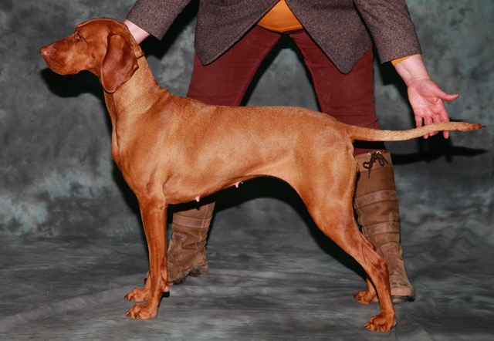1 Da Silva & Sexton’s ERTEKES LUCKY IN LOVE. Honest bitch, good expression, well-shaped eye, good neck and spring of ribs, moved well.

2 Cracknell’s PRINCESS LEIA. Smaller sized bitch but all vizsla, lovely shape, good hindquarters, moved well

Open B (4, 2)

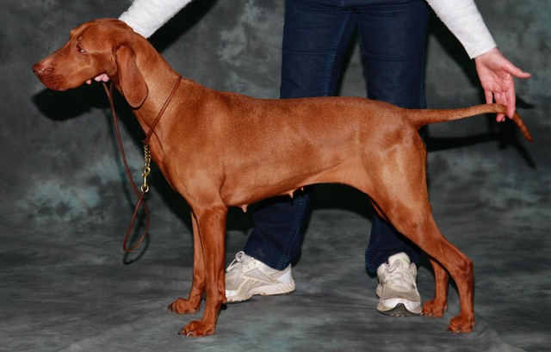1 Smith’s ZAVIS RHAPSODY. 6 year old honest bitch of good type, typical head, lovely neck and shoulders, good top line, well angulated rear. Moved well. Res Best Bitch

2 Cruickshank’s TOPAERIS SUMMER LOVE, 5 year old lovely bitch with clean head, good front and spring of rib, moved well.

Veteran B (5, 2)

Lovely class of veterans

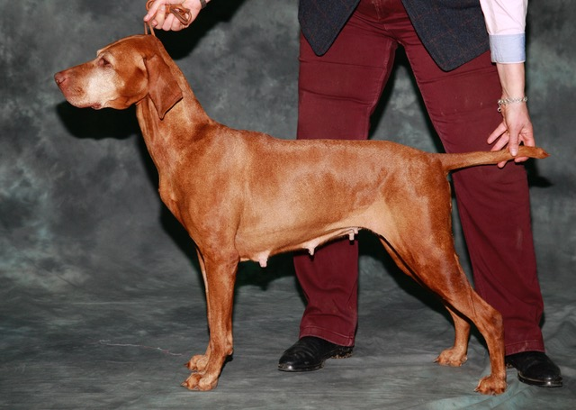1 Mills’ SH CH CARWCI’S PHOENIX. 9 year old worthy champion, still showing her good characteristics, thoroughly enjoying her day out as she showed in her movement.

2 Harris’ CH SZAJANI SIPOS JW SH CM. 8 year old workmanlike bitch, good for age, well balanced with good head and expression, strong neck, into level top line neat feet. Moved well

3 Cruickshank’s TOPAERIS LADY MARMALADE

Field Trial B (3, 1)

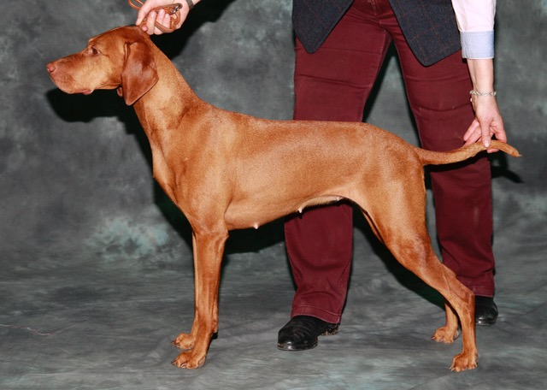1 Mills’ KARROUKI WINDRUSH D’LYLA JW SH CM. 5 year old with lovely head and expression, good eye colour, neat ears, good front and shoulders, level top line and good rear end. Moved with a happy disposition. Best Bitch

2 CH SZAJANI SIPOS JW SH CM

Champion Stakes D/B (1)

1 CH U CARDINAL MARKER

Brace (3, 1)

1 Mills’ Well matched pair, moved round ring in unison

2 Griffiths & Scott’s. Father and daughter combo, moved ok

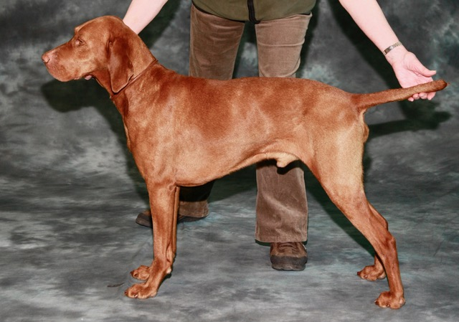John Wagstaff Special Working Memorial Stakes D/B (3, 1)

1 P PIROS BY A

2 SH CH C PHOENIX SH CM

Judge Jean Cameron (Kasprowy)